**CS480**

**PA 11: Labyrinth**

**12/07/15**

**Marco Rivas, Martin Revilla, Truman Chan**

**Overview**

**Extra Credit**

* Music/Sound effects
* PS4 controller
* Top 10 Scoreboard
* Multiple levels

**User Manual**

**To build and run the program:**

*cd build* Then: *make*

The executable will be put in the “bin” directory.

*cd bin* Then: *./Labyrinth*

**To clean (removing object files and executables):**

*cd build* Then: *make clean*

**Description**

The purpose of this assignment is to produce a 3D simulation of the Labyrinth game that is as realistic to the actual game as possible, yet still being a playable and an enjoyable experience for the end use.

There are three levels to the game. The goal for each level is marked by a spotlight! Once a goal has been reached, a checkpoint for the furthest level is saved. Avoid the holes and get to the final goal with the best time! If the ball falls into a hole, the ball will respawn at the last checkpoint. Access the menu to do stuff!

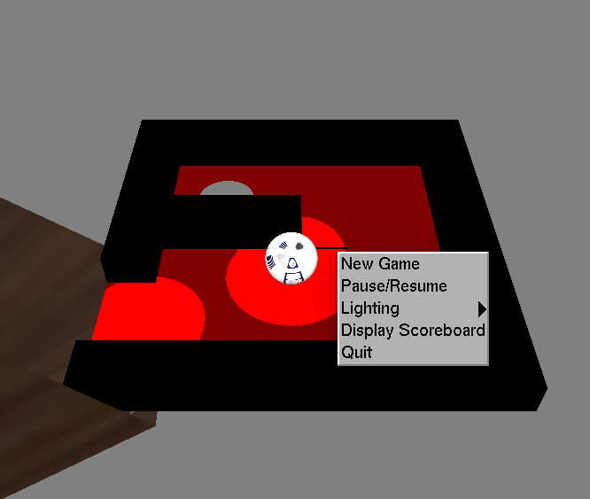

**Controls**

**Mouse**

| **Mouse Input** | **Action** |
| --- | --- |
| Hold left button and move | Tilt table |
| Right-Click | Open menu |
| Scroll Wheel up/down | Zoom in/Zoom out |

**Keyboard**

|  |  |
| --- | --- |
| **Keyboard Input** | **Action** |
| 'x' | Play/Pause song |
| Spacebar | Play next song |
| Up Arrow Key | Move camera up |
| Down Arrow Key | Move camera down |
| Left Arrow Key | Move camera left |
| Right Arrow Key | Move camera right |
| Esc | Exit game |

**PS4 Controller**

|  |  |
| --- | --- |
| **PS4 Input** | **Action** |
| Left Analog Stick | Tilt table |

**Technical Manual**

**Classes**

**main.cpp**

The main driver of the program. It calls on Graphics.cpp, GameEngine.cpp, MusicPlayer.cpp, GameController.cpp, and PhysicsEngine.cpp to create the game, and run it.

**GameEngine.h**

The logic of the game is handled in this class. It uses Graphics.h, PhysicsEngine.h, MusicPlayer.h, and GameController.h to properly update the state of the game.

**Graphics.h**

This class renders the labyrinth game including the maze, ball, and light. It’s also responsible for the scoring text shown on the screen. Assimp is used to load the textures for the game.

**PhysicsEngine.h**

Collisions in the game, primarily how the puck interacts with the paddles and the walls of the table, are done in this class. The Bullet library was used to handle collisions between bodies and how they would react.

**MusicPlayer.h**

This class stores the songs and sounds used for the game. “#include <SFML/Audio.hpp>” was used to play the WAV/OGG files loaded.

**GameController.h**

This class handles PS4 controller compatibility. “#include <SFML/Window.hpp>” was used to access joystick axis for its use in the game.

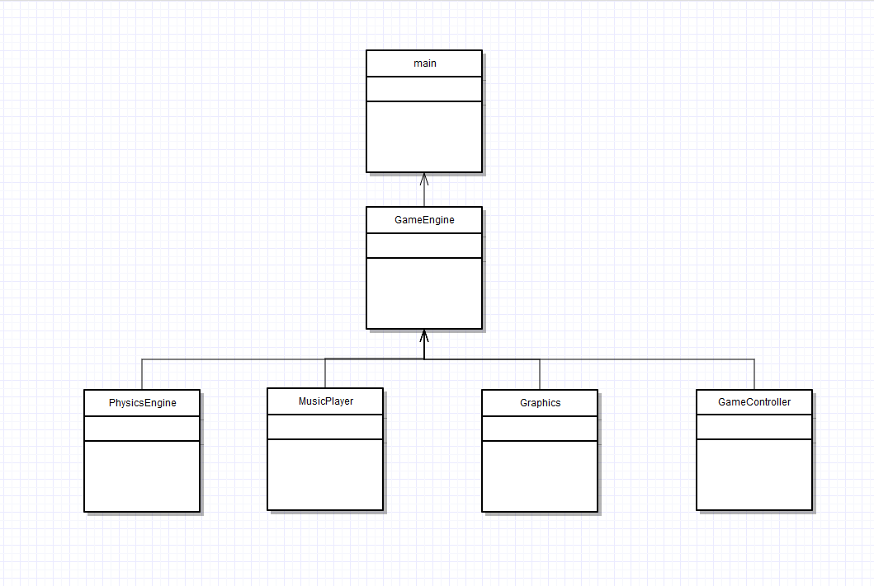

**Issues**

Segfaults occurred after quiting game with menu interactions. Issue was due to newest version of VMWare Player, and was resolved by downgrading to version 6. Also had an issue with the ball bouncing off the walls, resolved by the lowering restitution of the sphere.

Future edition will be Star Wars themed. Texture for level 1 would be the Death Star, level 2 would be Hoth, and level 3 would be Endor. Once all three mazes are completed, an advertisement for Star Wars: Episode VII, The Force Awakens, would play coming out December 18, 2015. Tickets available for purchase at www.Fandago.com/TheForceAwakens.